Studies of Love in Religion 2
Loving the Planet: Interfaith Essays on Ecology, Love and Theology
Edited by Paul S. Fiddes. Oxford: Firedint Publishing, 2023.
(£12.25/ $15.00. Available from Amazon)
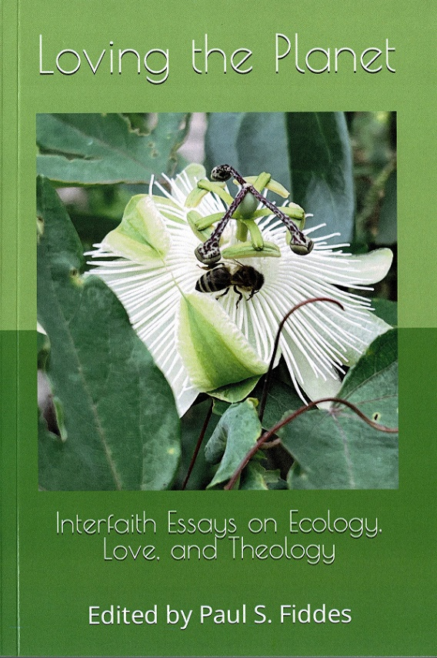

In this book, Jewish, Muslim and Christian scholars explore the question: what can it mean to love Planet Earth? Many people will profess casually that ‘I love nature’, but can that love make an actual impact on the life of our distressed and ravaged world? The writers consider how love might be, not just an emotional extravagance, but a practical response to the ecological crisis into which the human and non-human world is plunged at the present time. Correspondingly, they enquire whether this love can be reciprocated by non-human forms of life and even by apparently inanimate objects. As believers from three main Abrahamic faiths they ask how this love for nature connects both with the act of loving God and with receiving the love that God bestows on all creation. Thus they dare to maintain that love of God can be a practical response to environmental emergency.
1 Love, Intersubjectivity, and the Natural World
by Emily A. DeMoor
2 Learning to Love Again: Rediscovering the Earth as Sacred
by Celia Deane-Drummond
3 Are Jews Commanded to Love the Planet?
by Melissa Raphael
4 Nature as Beloved and Mentor: The Symbolic Representation of Nature in Persian Poetry
by Amir H. Zekrgoo and Leyla H. Tajer
5 Creation as a Divine Revelation in Judaism: Love of Nature as a Way to Love God
by Naftali Rothenberg
6 Islamic Finance, a Green Economy, and its Contribution to Loving a Greener World
by Tareq Moqbel
7 ‘A Mirror of infinit Beauty’: Contemplating Love in the Natural World with Thomas Traherne
by G. P. Marcar
8 Summing up: Outlines of an Eco-Love-Theology
by Paul S. Fiddes
Reviews:
“In ‘Loving the Planet’, Paul Fiddes has brought together a very fine group of religious scholars. This is a book which communicates a fundamental re-orientation to planet and world in the light of faith; but it also does so too in terms of what can be read as a re-orientation of faith in the light of contemporary science and philosophy. The quality of these articles is deeply impressive, and there is an exciting sense that this book is pushing at the boundaries of both science and religion in new ways, as each is invited to think in new and radical terms about the other, as we seek to weave a common future together.”
- Oliver Davies, Emeritus Professor of Christian Doctrine, King’s College, London, author of A Theology of Compassion.
“What would it be to love the planet, rather than merely to care for it according to passing self-interest? Could such love motivate a sufficient and durable response to the climate emergency? And how might it be grounded in love for God and in God’s love for humanity? This deeply thought-provoking collection of essays offers a fascinating range of Christian, Islamic, and Jewish responses to these and other urgent questions, which will be of the greatest interest not only to scholars of religion, but also to philosophers, sociologists, environmentalists, and historians of ideas - indeed to all who are puzzled that, despite widespread fear of ecological disaster, our earth and its environment are still not treated as sacred.
- Simon May, Author of Love: A New Understanding of an Ancient Emotion

Return to:
Love in Religion – Project of the Oxford Centre for Christianity and Culture at Regent's Park College, a Permanent Private Hall of the University of Oxford

